CPSC 240: Computer Organization and Assembly Language

Assignment 07, Fall Semester 2023

CWID:_885857847________________ Name:Kush Patel________________________

1. Download the “CPSC-240 Assignment07.docx” document.
2. Design the "input.asm" program, input 9 values from 1 to 9 from the keyboard, find out the multiples of 3 from the input values, and display the multiples of 3 in the terminal emulator window. The corresponding C/C++ code is as follows:

char msg1[] = "Input a number (1~9): ";

char msg2[] = " is Multiple of 3.";

char buffer;

char num;

char ascii[10];

register int r10 = 0;

do {

cout << msg1;

cin >> buffer;

ascii[r10] = buffer;

r10++;

} while(r10 < 9);

r10 = 0;

do {

num = atoi(ascii[r10]);

if(num%3 == 0) {

cout << ascii[r10] << msg2;

}

r10++;

} while(r10 < 9);

1. Assemble the "input.asm" file and link the "input.o" file to get the "input" executable file.
2. Run the "input" file to display the input value and multiple of 3 in Terminal Emulator window.
3. Insert source code (input.asm) and simulation results (Terminal Emulator window) at the bottom of the document. Write an analysis to verify the simulation results.
4. Save the file in pdf format and submit the pdf file to Canvas before 23:59 pm on 11/02/2023.

Sample output:

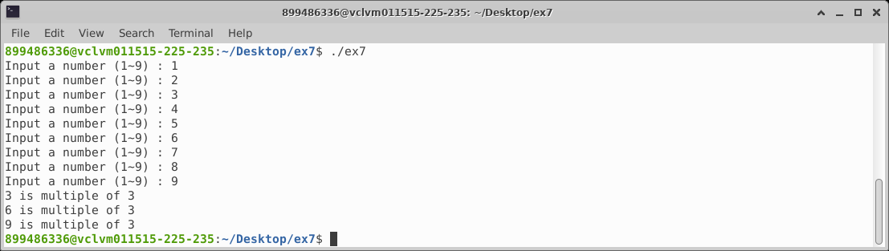

Alternatively, the corresponding C/C++ code can be replaced as follows:

char num;

char buffer;

char msg1[] = "Input a number (1~9): ";

char msg2[] = " is multiple of 3.";

register int r10 = 0;

do {

cout << msg1;

cin >> buffer;

num = atoi(buffer);

if(num%3 == 0) {

cout << buffer << msg2;

}

r10++;

} while(r10 < 9);

Sample output:

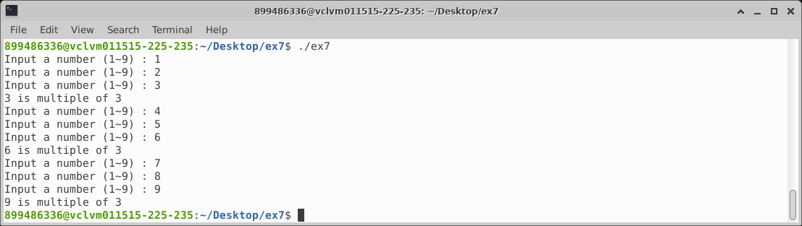

[Insert input.asm here]

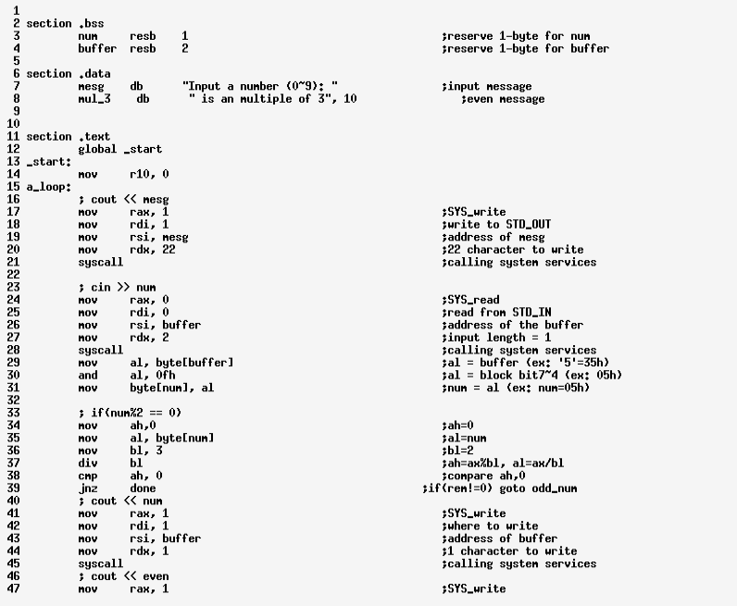

[Insert input simulation result here]

[Insert input simulation result verification here]

